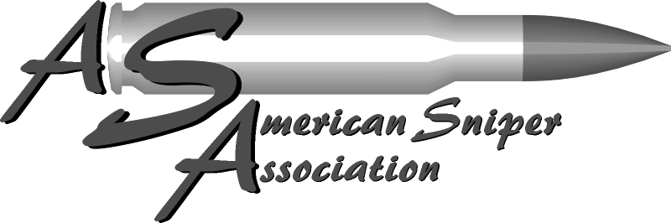

SNIPER UTILIZATION SURVEY FORM

AGENCY ________________________________________________________________________________________

ADDRESS ________________________________________________________________________________________

CITY & STATE ___________________________________________________________________________________

PHONE NUMBER ___________________________ CONTACT PERSON ___________________________

SWAT TEAM – YES NO / SNIPER TEAM - YES NO / SNIPER SHOOTING - YES NO

________________________________________________________________________________________________

TYPE OF INCIDENT - O BARRICADE O HOSTAGE O SUICIDAL SUBJECT O SNIPER O OTHER

DATE ________________________________ TIME OF DAY _______________________________

WEAPON _____________________________ CALIBER & BULLET ________________________

SHOT DISTANCE APPROX. _______________________ POSITION __________________________________

TRIPOD UTILIZED (BRAND) __________________________________________________________

NIGHT VISION DEVICE UTILIZED (BRAND) ____________________________________________

SHOT PLACEMENT – O HEAD O BODY O ARM O LEG

RESULT – O FATAL O INJURY-RECOVERED

INTERMEDIATE BARRIER - O YES O NO DID ROUND STAY IN TARGET - O YES O NO

ADDITIONAL COMMENTS

__________________________________________________________________________________________________
__________________________________________________________________________________________________

__________________________________________________________________________________________________

SURVEYER’S INITIALS ________________ COMPLETED ___________________

AMERICAN SNIPER ASSOCIATION 863-385-7835 WWW.AMERICANSNIPER.ORG

