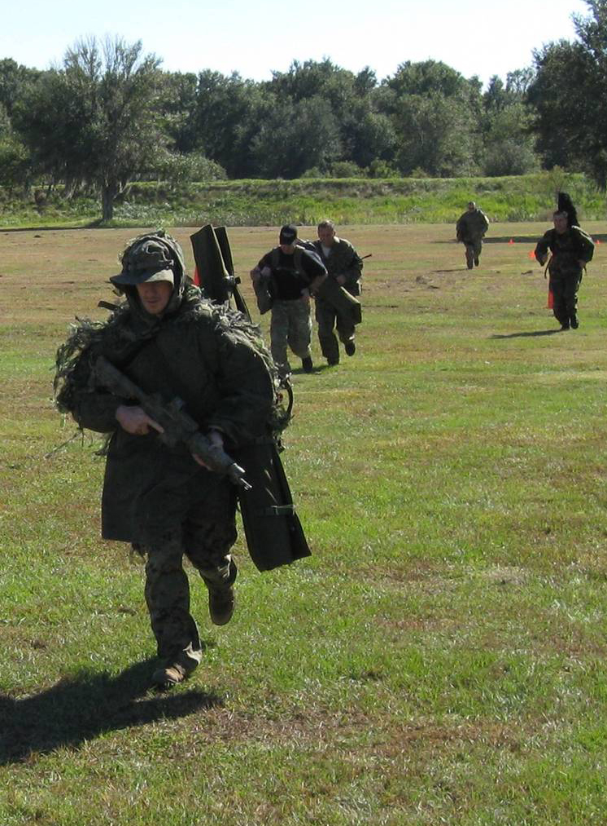



Sniper Functional Fitness Test

Copyright 2008 © Snipercraft, Inc.

COPYRIGHT NOTICE: This testing process and the documentation attached to it are the intellectual property of Snipercraft, Inc. No portion of this test, or the accompanying documentation is to be copied or distributed, in any format, without the expressed written consent of Snipercraft, Inc.

Snipercraft, Inc. 6232 Apple Road, Sebring, FL 33875
863-385-7835 – www.snipercraft.org
Sniper Functional Fitness Test

Rationale: The position of police sniper requires a high level of physical fitness for the officer to be able to perform necessary job tasks safely and correctly. These include individual movement skills, navigating obstacles and carrying personal equipment. By the nature of SWAT calls, the sniper must also possess a level of conditioning which will allow him to handle physical stress and quickly recover from exertion, and have the endurance and stamina to be able to continue perform at high mental and physical levels for an extended period of time. This testing program is intended to provide the sniper with a gauge of his current level of fitness in relation to functional fitness demands.

The standards and scoring are intentionally age neutral. In the real world of tactical operations, no special compensations will be made for an older sniper. Expectations of his performance level will be the same as that for a younger sniper. Therefore, the standards will reflect those same expectations.

Disclaimer Note: We recognize that SWAT personnel and snipers come in both genders. The use of masculine words nouns like “he” and “his” do not connote any preferences, prejudices or limitations. They should be read as gender neutral.

Equipment: The testing will be performed on an open field, providing at least 100 yards of flat, unobstructed area for movement portions of the test. Administrators will need stopwatches, a tape measure and a scoring sheet. Traffic cones or something similar will be used to mark distances and lanes.

Snipers will perform most portions of the test dressed in their regular callout uniforms, which must include long sleeve BDU top, or long sleeve t-shirt, boots, gun belt and unloaded sidearm (dummy gun is acceptable). For the Core Strength and Broad Jump phases, the BDU top and gun belt can be removed. For Stage One and Stage Three portions of the test, snipers will be required to carry their unloaded sniper rifles in a transport case. For the Functional Strength portion, snipers will need their rifle case as well.

Testing protocols: The test is divided into three stages, Movement to Callout, Functional Strength, and Callout Endurance. Each stage will be completed, one at a time. Snipers will be allowed five minutes to rest and prep for the next stage. Failure to start the next stage on time will result in a failure for that stage.

Scoring: Based on statistical data collected during six months of control testing, a scoring range has been established. Point values have been assigned. The complete scoring explanation and point value grid is attached.

There are 500 total points available. Snipers will be required to achieve an aggregate score of 375 points (75%) to pass the SFFT. If a sniper demonstrates a weakness in a particular area, he can make up points with a superior performance in another.

Testing:

Stage One – Movement to Callout – Total Distance 200 yards

This stage is intended to test the sniper’s fitness level against the energy expenditure of executing individual movement skills under stress.

Sniper will stand at starting line with his rifle in a transport case. On the signal to start, the sniper will sprint 50 yards to Cone #1. He will then drop to his hands and knees and execute a high crawl for 25 yards to Cone #2. Upon reaching the cone, the sniper will drop to the ground and execute a low crawl to Cone #3. The sniper will circle the cone, turning 180 degrees while remaining in contact with the ground, and will then execute 20 pushups. Concluding the pushups, the sniper will execute a low crawl to Cone #2. Reaching that cone, the sniper will rise to his hands and knees and execute a high crawl to Cone #1. Upon reaching the cone, the sniper will rise to his feet and sprint to the finish line. Time stops when the sniper crosses the line.

START
Sprint
High Crawl
Low Crawl

#1

#2

#3

50 Yards
25 Yards
25 Yards

NOT TO SCALE

Procedures:

High crawl is properly executed with the sniper moving forward with six points of contact with the ground. This includes hands, knees and feet.
Low crawl is properly executed with the sniper moving forward while maintaining full contact with the ground. This includes elbows, knees, feet and belt buckle.

The turn will be executed while maintaining full contact with the ground.

Minimum Standard: 5:18

Stage Two – Functional Strength

This stage is intended to test the sniper’s basic functional strength levels. The tests focus on lifting strength and stamina, core strength and lower body power.

First Phase – Overhead Equipment Lift

This test will be administered using the sniper’s rifle, inside its case. The case will be placed at the sniper’s feet. On the signal to start, the sniper will lift the case from the ground, over his head with arms fully extended, then returned to the ground. This counts as one repetition. The sniper will complete as many repetitions as possible in two minutes.

Minimum Standard: 40 lifts

Second Phase – Core Strength

While wearing t-shirt or BDU top (or flight suit), the sniper will assume “The Plank Position,” and continue to maintain it for as long as possible. The time starts once the sniper is in position and stops as soon as any part of his body other than his forearms and toes make contact with the ground.

Plank Position Procedure:
  - Start by lying face down on the ground. Place your elbows and forearms underneath your chest.
  - Prop yourself up to form a bridge using your toes and forearms
  - Maintain a flat back and do not allow your hips to sag towards the ground.
Minimum Standard: 1:18

Third Phase – Standing Broad Jump

While wearing t-shirt or BDU top (or flight suit), the sniper takes up a position, standing behind the start line. On his initiative, the sniper will execute a standing broad jump forward, as far as he can. The distance of the jump will be measured from the start line to the heels of the sniper upon landing. The sniper will be afforded two jumps, and the longer of the two will be recorded for score.

Standing Broad Jump Procedure:

The sniper stands behind a line marked on the ground with feet slightly apart. A two-foot take-off and landing is used, with swinging of the arms and bending of the knees to provide forward drive. The sniper attempts to jump as far as possible, landing on both feet without falling backwards.

Minimum Standard: 78 inches

Stage Three – Callout Endurance

This stage is intended to test the sniper’s current level of stamina and endurance after sustained energy expenditure.

The sniper will run 440 yards (1/4 mile), wearing full callout uniform and carrying his rifle in a transport case (soft or hard).

Minimum Standard: 2:41

Copyright 2008 © Snipercraft, Inc.

COPYRIGHT NOTICE: This testing process and the documentation attached to it are the intellectual property of Snipercraft, Inc. No portion of this test or the accompanying documentation is to be copied or distributed, in any format, without the expressed written consent of Snipercraft, Inc.

